IMPORTANT: Before using the WebEx tool in Blackboard, you must login to ConnectCUNY.webex.com to set up your WebEx account. Please see detailed instructions for how to complete this part of the process. Once you have set up your WebEx account in ConnectCUNY, you can follow this guide to using WebEx within Blackboard.
Using WebEx in Blackboard
The WebEx Educator Connection tool allows you set up online meetings in an existing course so that your students can join the meeting from within Blackboard. Below are instructions for setting up your WebEx account within your Blackboard course site and creating virtual meetings.
- Creating WebEx menu link for easy navigation
A. In your Blackboard course site, click on “Add menu item” (+ button) in upper right corner:
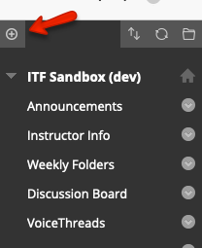

B. From the drop-down menu, choose “Tool Link”:
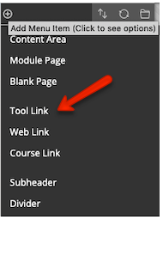
C. Name your new menu item “WebEx” and choose “connectcuny WebEx”. Make sure to tick the box that reads “Available to Users”:
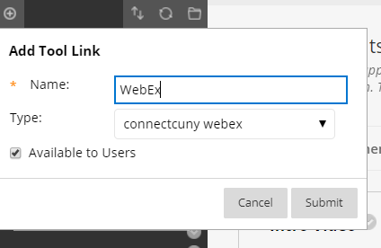

- You should now see a WebEx menu item at the bottom of course menu. Click on the newly created menu link:
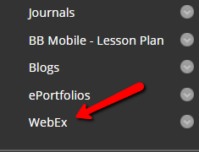

A. The WebEx LTI will launch.
B. Click on the “Setup” tab.
C. Check “Virtual Meetings” to allow students to meet with you in a virtual space.
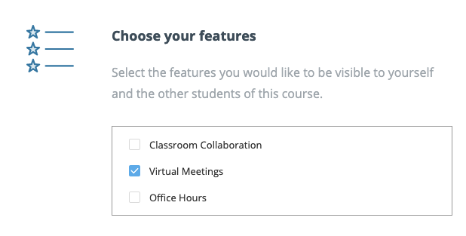

NOTE: We don’t recommend turning on “WebEx Attendance Grading” or “Reminder Bot”.

3. Once you have chosen and enabled Virtual Meetings, return to “Virtual Meetings” tab and set up a new meeting by clicking on the blue New Meeting button on the top right of the screen. You can choose a name for your meeting (e.g. “Student Hour”), set the date and time, and “Create Meeting.” You can set the meeting to be a one-time meeting or a recurring meeting.

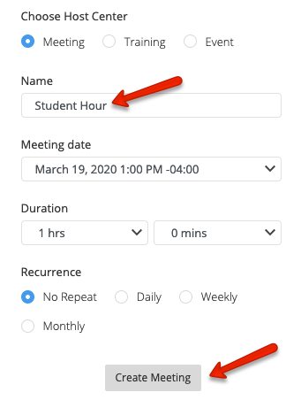

4. You will be listed as the “Host” for your meeting. After you have set up a meeting and are ready to begin, click the blue “Host” button to start meeting. You will be asked to login using your @cuny.login.edu credentials (same as Blackboard or CUNYfirst). You will be asked to download desktop app and will be taken to WebEx for your meeting.

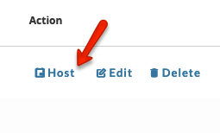
Final Note:

The benefit of connecting to WebEx through Blackboard is that your students will be able to join meeting from your course site. They will be able to do this through the “WebEx” menu item you just created.

For students:

1. Click on the “WebEx” menu item. You will be brought to the “Virtual Meeting” tab.
2. In the “Virtual Meeting” tab you will see meetings created by your instructor.
3. Click +Join Meeting. You will be asked to download desktop app, which you should do. You will be taken to WebEx to attend your meeting.

